Glow Grove Spa – Services
Cervical Release Therapy
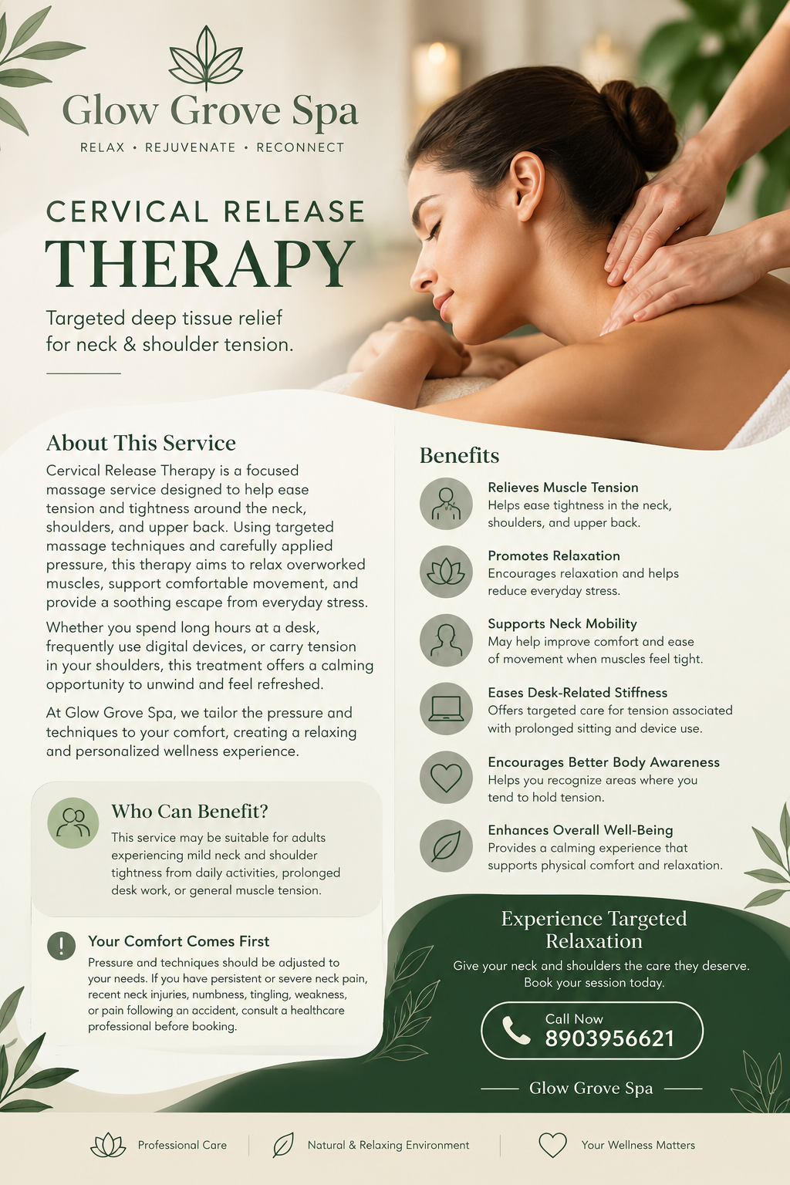

Swedish Relaxation Massage
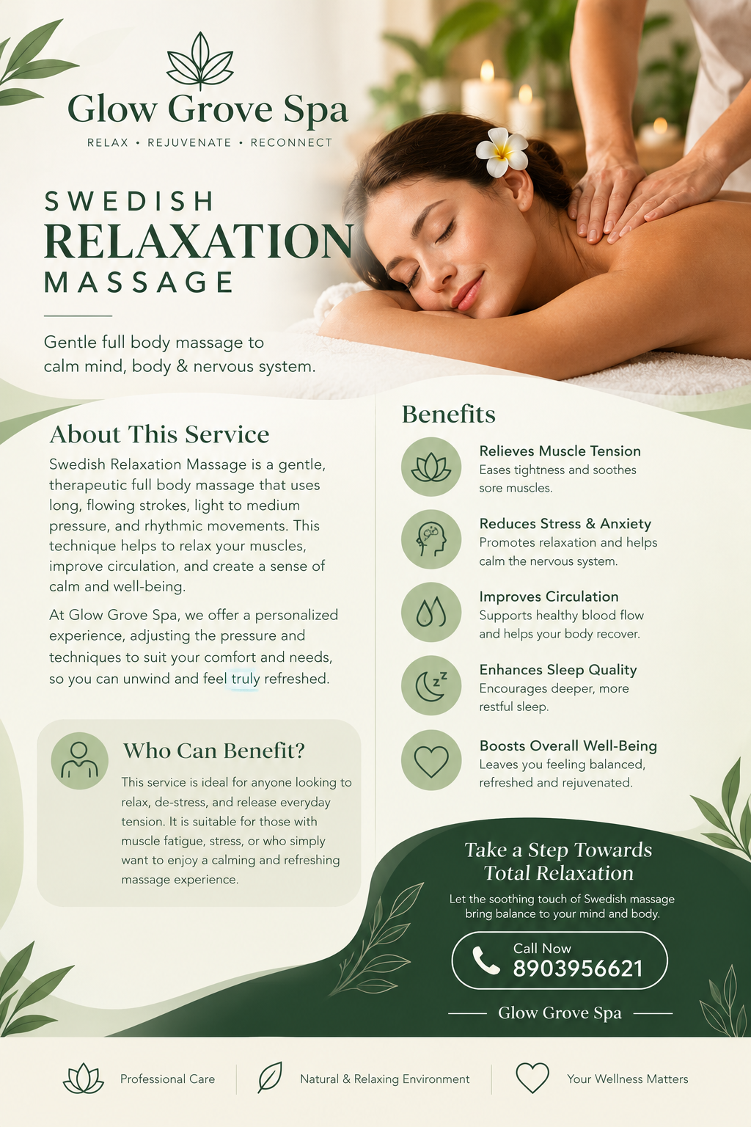

Signature Body Ritual
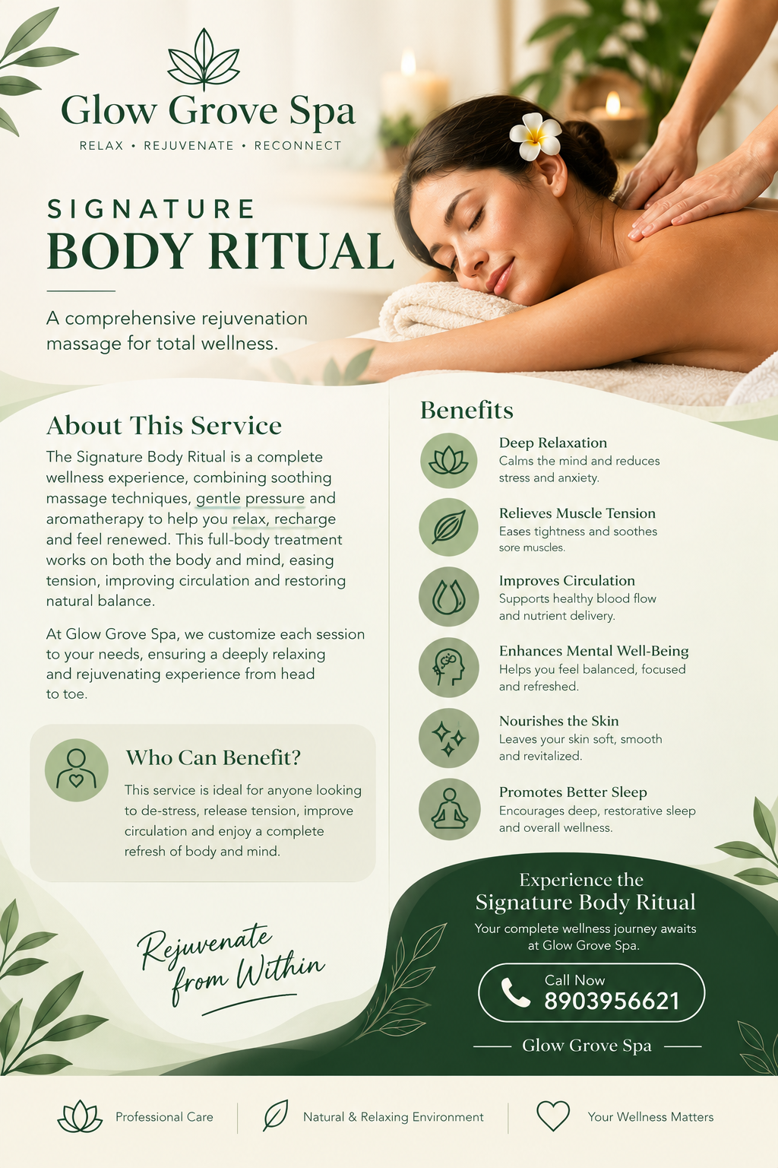

Chocolate Indulgence Massage
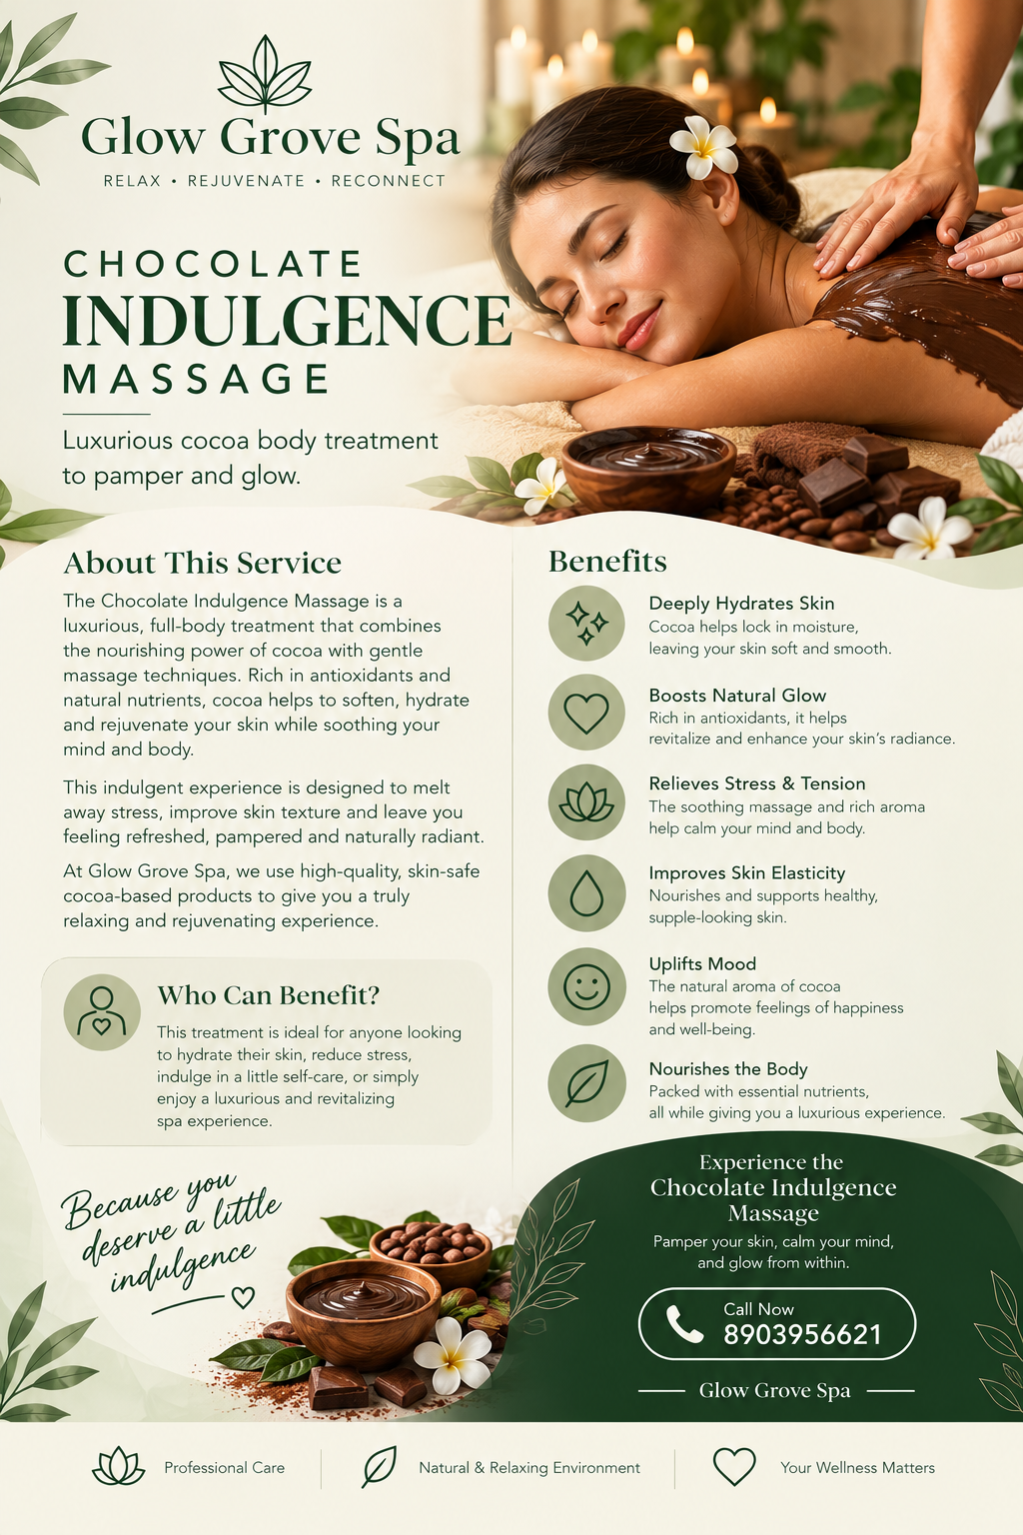

Sacred Feminine Wellness(Yoni Massage)
